TABLE OF CONTENT
I . EXECUTIVE SUMMARY
- MARKET
- OBJECTIVES
- PROPERTY: DROOGEKLOOF
- BUSINESS PLAN:

5.1. CHICKEN FARMING
5.2. SHEEP FARMING
5.3. PIG FARMING
An existing Agriculture Business that has been operating for 35 years. It is a sought-after name of good quality products in the Agriculture of Africa.
Key to success:
- 4 integral products that fit into each other to make the most profit before it leaves the farm
- Unique products produced with high quality standards.
- Green farming looking after the environment.
Products:
Indigenous Village Chicken
- Beef
- Pecan Nuts
- Guest House
- MARKET
Farming with very unique products that are in high demand in Africa. The markets for these products are growing at such a rate, demand will always exceed supply due to the quality of the products and the excellent service that the company is giving to the customer. All products are produced to International standards set out by the company who is the market leader in Africa with all certifications and accreditations to its name and brand.
Animal welfare must be adhered to always, with the smallest carbon footprint to be left in all production systems. We must satisfy the needs of the customers in every step of the process.
- OBJECTIVES
  - Strict financial controls
  - Never ending pursuit to stay the market leader
  - Ensure customer needs are met

- PROPERTY: DROOGEKLOOF
Droogekloof RE/5:
- 20,3856 ha
- Well-developed chicken farm
- 50 000 chicken capacity
- 2 x 3-bedroom houses
- 2 x strong boreholes
- 2 x large sheds 12 x 20m
- On Mabula road R516
- 100 KVA transformer
- I x 120 0001 reservoir
DROOGEKLOOF RE/5:
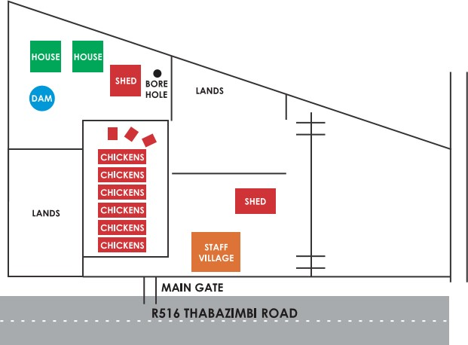
5. BUSINESS PLAN:

5.1. CHICKENS
Per 4 o Id c | R40x2000 | 80000
 | 02) | (18)
 | 1000 @ R40000 | 1000 @ R40000
FEED: 8 + 1 4 weeks | 2.8kg | 5.9kg
= R4.20/kg | RI 1.76 | R24.78
 | RI 1 760.00 | R24 780.00
WATER: 100ml per chick per day | R800.OO | RI 400.00
VACCINES: @R3.70 | R3 700.00 | R3 700.00
LABOUR: | R640.OO | RI 120.00
MORTALITIES: 2% | R900.OO | R900.OO
COST: | R57 800.00 | R71 900.00
SALES: 980@ R75/980@R95 | R73 500.00 | R93 100.00
PROFIT PER WEEK: | RI 5 700.00 | R21 200.00
PROFIT PER YEAR: | R817 400.00 | RI 102400.00
TOTAL PROFIT PER YEAR: | RI 918 800.00

5.2. SHEEP

• 5xDORPER RAMS • 200xDORPER EWES
• LAMB% = 150%
300 LAMBS:
150 MALE | @R75.OOx30kg | R2250.OO
 | 150 x | R337500.00
150 FEMALE | @R2500.OO | R375000.OO
COST: | INCOME: | R712500.oo
Dip & Vaccines: |  | R24 000.00
Lamb Feed: |  | R75000.00 R99 000.00
 | PROFIT: | R613 500.00

5.3. PIGS
. I x BOAR

• 10xsows
12x Piglets per sow per year
= 120 @RIOOO.OO  COST: | R120000.OO
Dip & Vaccines: | R20000.OO
PROFIT: | RIOOOOO.OO

